ECE4250 Lab 2

6-bit Full Subtractor

2/18/2021

Sterling LaBarbera

14096504

# Objective

In this lab our goal was to make 6-bit full subtractor using 6 connected full subtractors.

# Lab Work

For a single full subtractor, there are 3 input bits and 2 output bits. Inputs are the minuend, subtrahend and borrow in bits, and the outputs are the difference and borrow out bits. Borrow out of a lower subtractor goes the borrow in for the next higher subtractor. The borrow out of the most significant bit indicates if the result is negative since it will only happen if the minuend is less than the subtrahend. The truth table below was used to get equations for the difference and borrow out bits.

The difference: $Z<=X⊕Y⊕Bin$

Borrow Out: $Bo<=X^{'}Bin+X^{'}Y+YBin$ 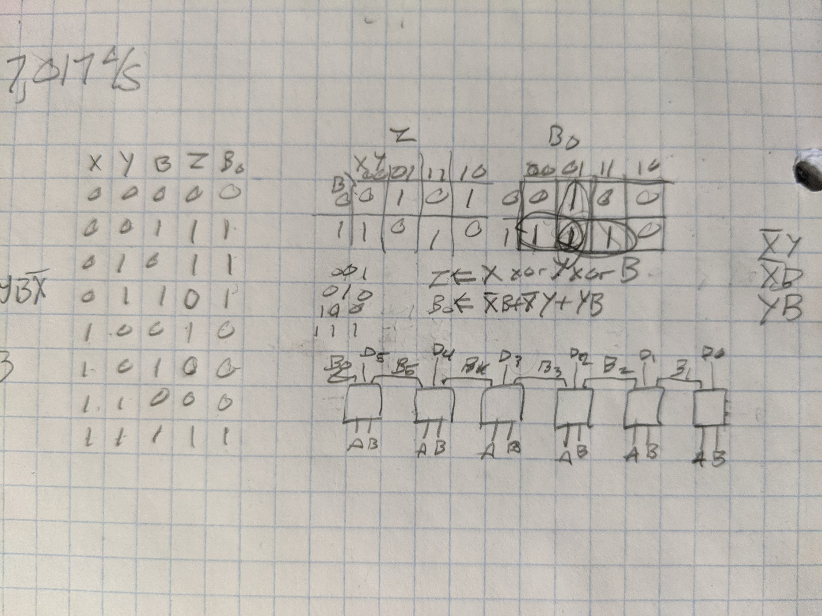

Figure . Truth Table and Block Diagram

# Conclusions

This lab was a straightforward extension of the 4-bit full adder. The main issues I had this week were getting modelsim installed on my home computer, and a mapping order error, where I had the Bin and difference bits swapped in the port map. Swapping the order fixed it quickly.

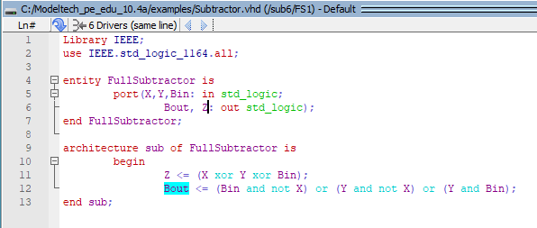

Figure . Full Subtractor Code

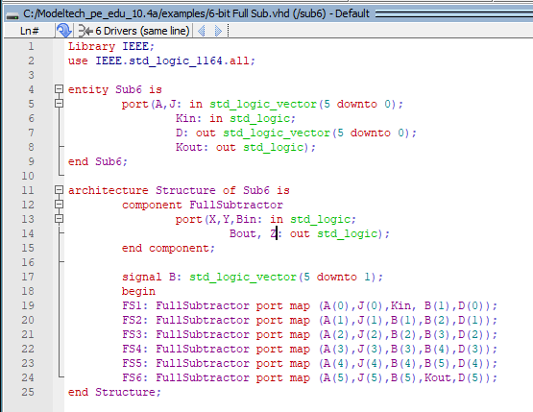

Figure . 6-Bit Full Subtractor Code

The subtraction equation is $A-J=Diff$.

Bin is always zero since there is no borrow coming in for the first subtractor. Bout is only 1 if the value is negative.

|  |  |  |  |  |
| --- | --- | --- | --- | --- |
| A | J | Bin | Diff | Bout |
| 01 | 02 | 0 | 3F | 1 |
| 0F | 0F | 0 | 00 | 0 |
| 0A | 05 | 0 | 05 | 0 |
| 10 | 06 | 0 | 0A | 0 |

Figure . Simulation Data Table

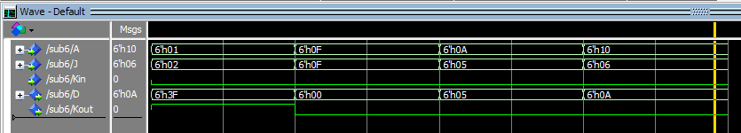

Figure . Simulation Results